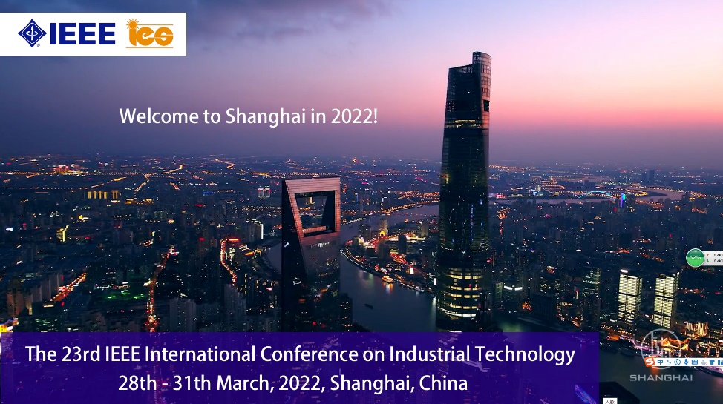
ICIT 2022 Special Session Proposal
Title of the Proposal:

−The name, a photo, a very short bio, contact details and IEEE IES membership of the Session
Organizer: Organizer 1:
Organizer 2:
Organizer 3:

−Technical Outline of the Session and Topics:
Outline of the Session
Topics of the Session
o xxx
o xxx
o xxx
:

−Potential Contributing Authors (names, affiliations and emails):
o xxx
o xxx
o xxx
:

−Potential Reviewers (names, affiliations and emails, at lease 20):
o xxx
o xxx
o xxx
:

−IEEE IES Technical Committee Sponsoring the Special Session (if any):
xxx
−Other:

